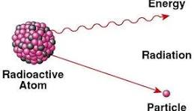
Radioactivity
Radioactivity is the spontaneous emission of energy or particles from the unstable nucleus of an atom. This emission allows the atom to achieve a more stable nuclear state. The three primary types of radioactive emissions are alpha particles, beta particles, and gamma rays—each with distinct properties and effects.

Types of Radioactive Emissions
- Alpha Radiation (α):
Alpha particles consist of two protons and two neutrons (identical to a helium nucleus). They have low penetration power and can be stopped by paper or skin, but are harmful if ingested or inhaled.
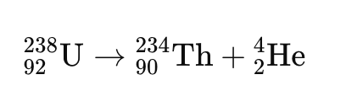
- Example Reaction:

(Uranium-238 decays into Thorium-234 by emitting an alpha particle.)
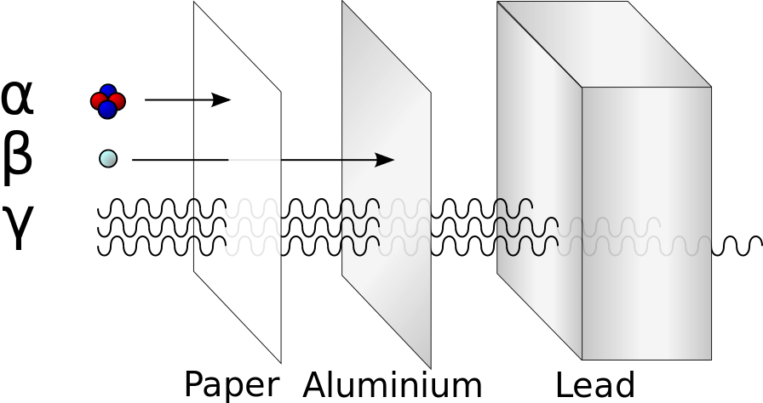
- Beta Radiation (β):
Beta particles are high-speed electrons (β⁻) or positrons (β⁺) emitted when a neutron transforms into a proton or vice versa. They are more penetrating than alpha particles and can pass through thin layers of material like plastic or glass.
- Gamma Radiation (γ):
Gamma rays are high-energy electromagnetic waves released from an excited nucleus. They often accompany alpha or beta decay and are highly penetrating, requiring thick lead or concrete for shielding.

Nuclear Fission in Power Reactors
In addition to natural radioactive decay, nuclear fission is a man-made nuclear reaction used in nuclear power plants to generate energy. In this process, a heavy nucleus splits into two smaller nuclei upon absorbing a neutron, releasing a large amount of energy and additional neutrons that sustain a chain reaction.

Example Fission Reaction:

This reaction is the foundation of energy production in nuclear reactors, where the heat generated is used to produce steam and drive turbines for electricity generation.

